**F.3 Mathematics – Transformations 1 (Reflection & Rotation)**

**Name: _______________________________**

**Class: 3____ ( )**

**Date: ____________________**

# REFLECTION

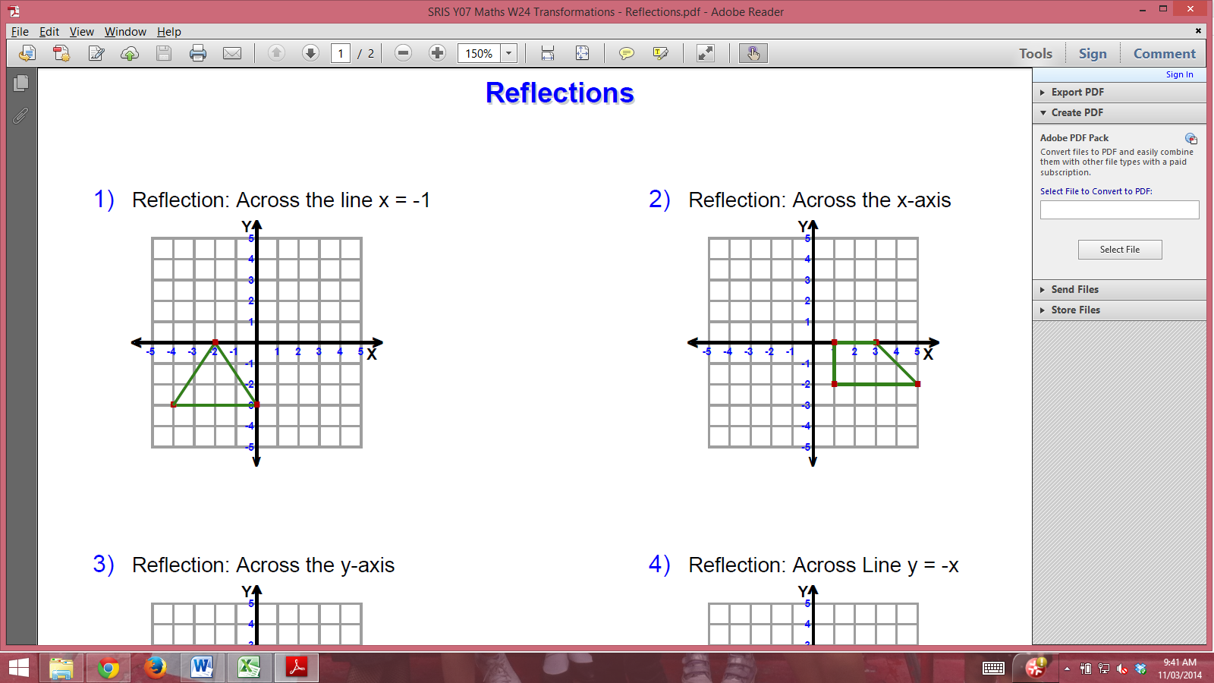

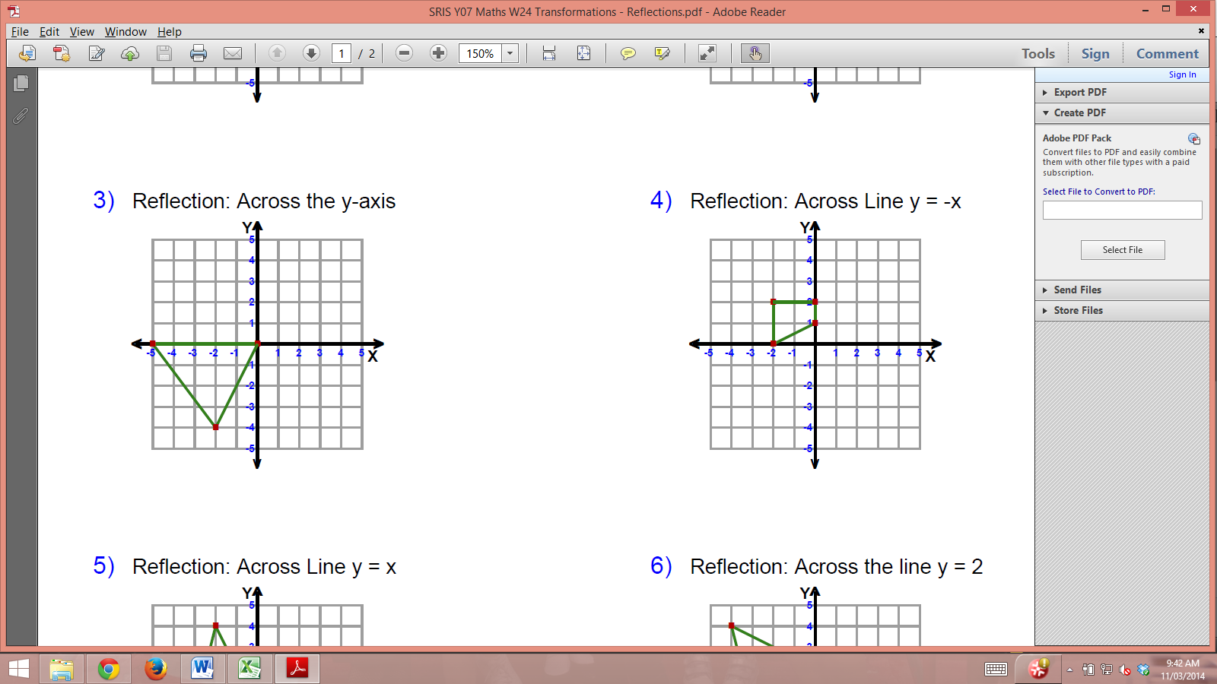

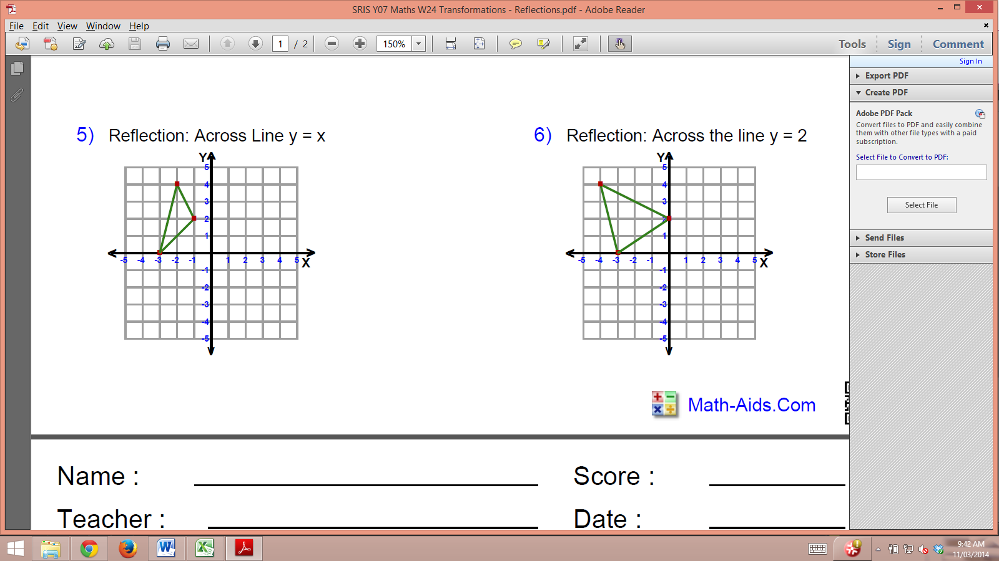

# ROTATION

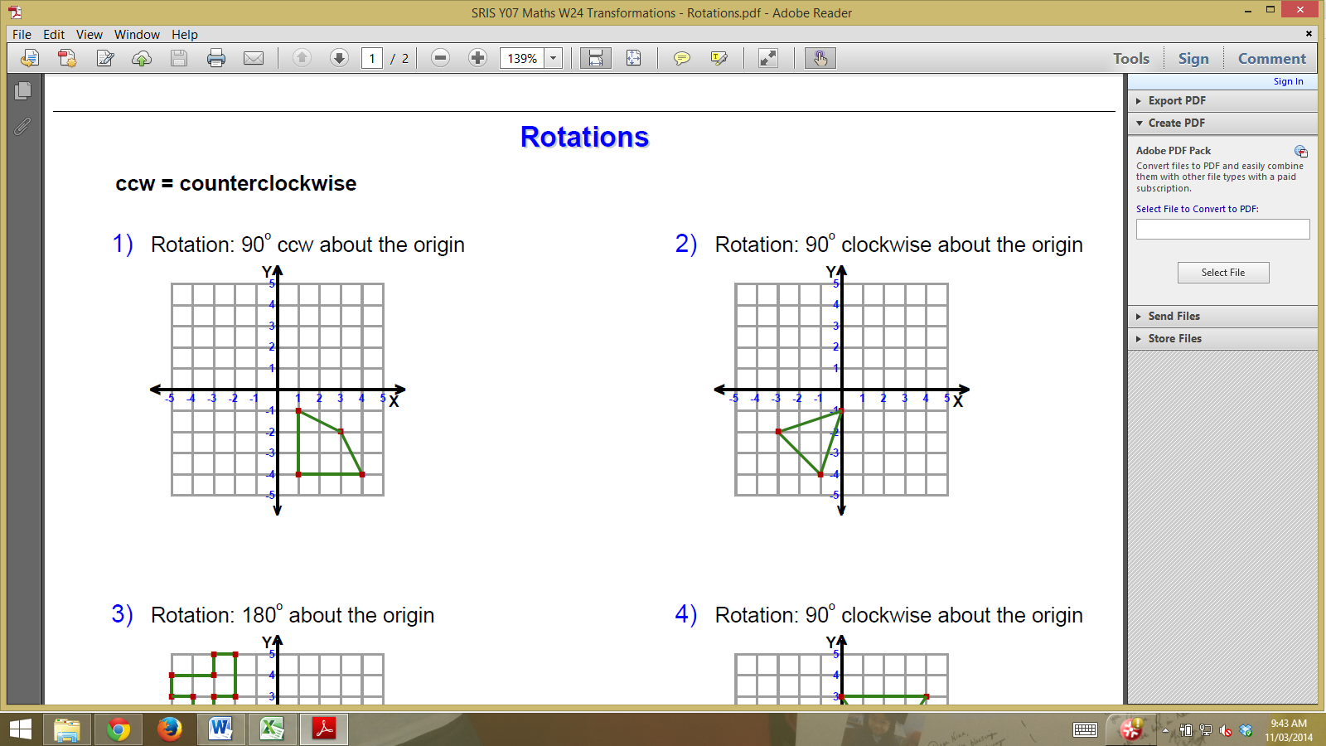

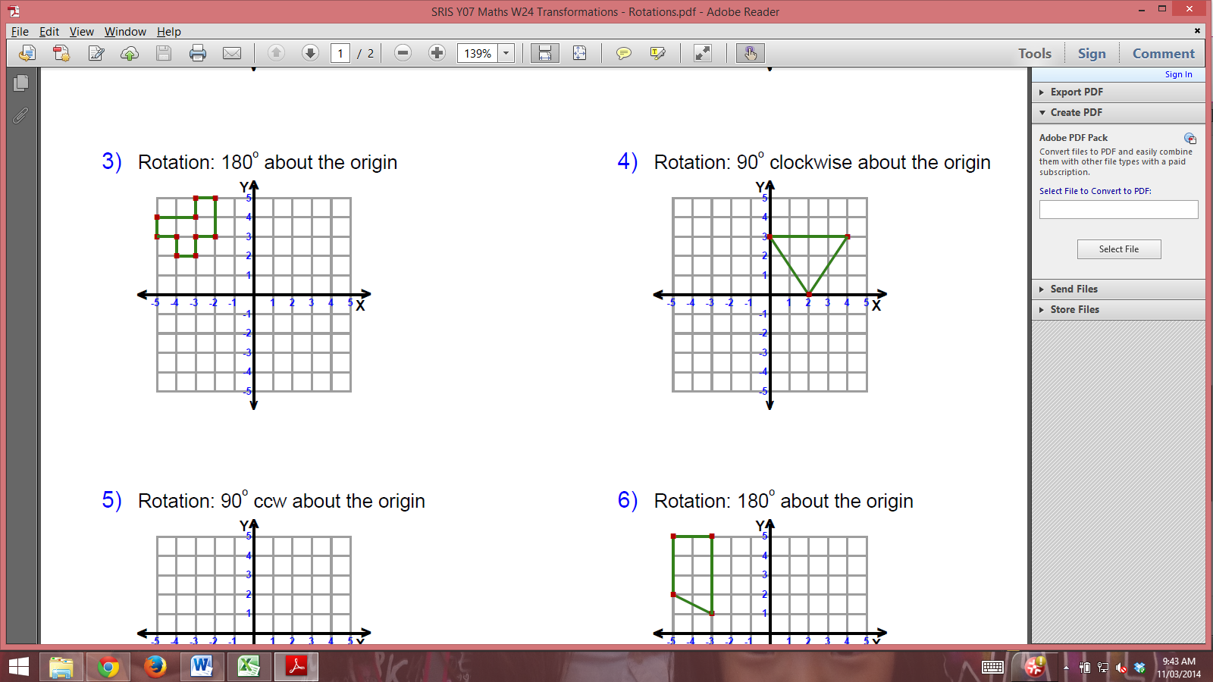

about (0,3)

about (-2,3)

about (-1,0)

about (-2,0)

