F.3 Mathematics – Transformations 2 (Translation & Enlargement)
Name: _______________________________
Class: 3____ ( )
Date: ____________________

TRANSLATION (draw the translated shape and state the translation vector)

ENLARGEMENT

Enlarge the shape:  - by scale factor 2, and  - centred at the origin  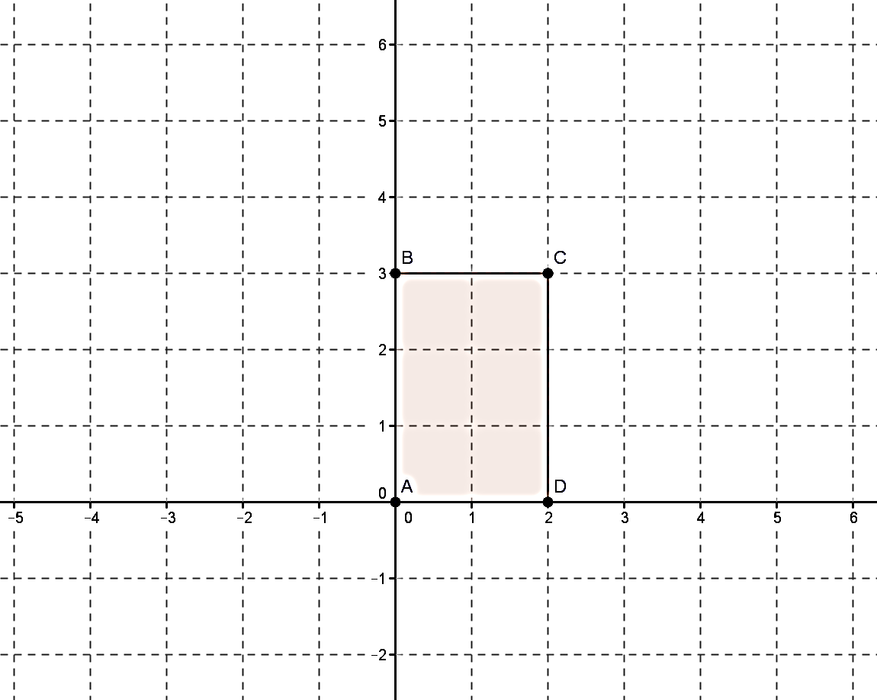 | Enlarge the shape:  - by scale factor 2, and  - centred at (3, 2)  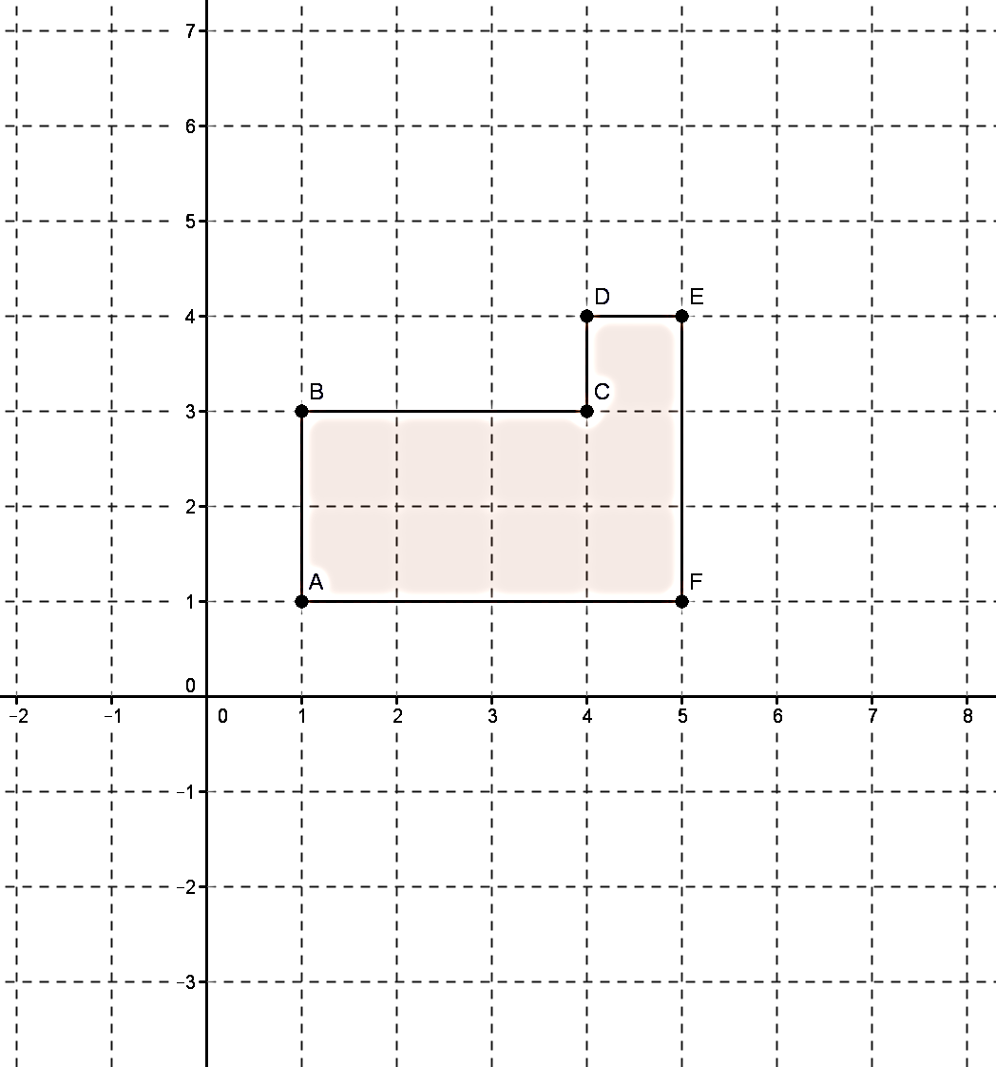
Enlarge the shape:  - by scale factor 3, and  - centred at A  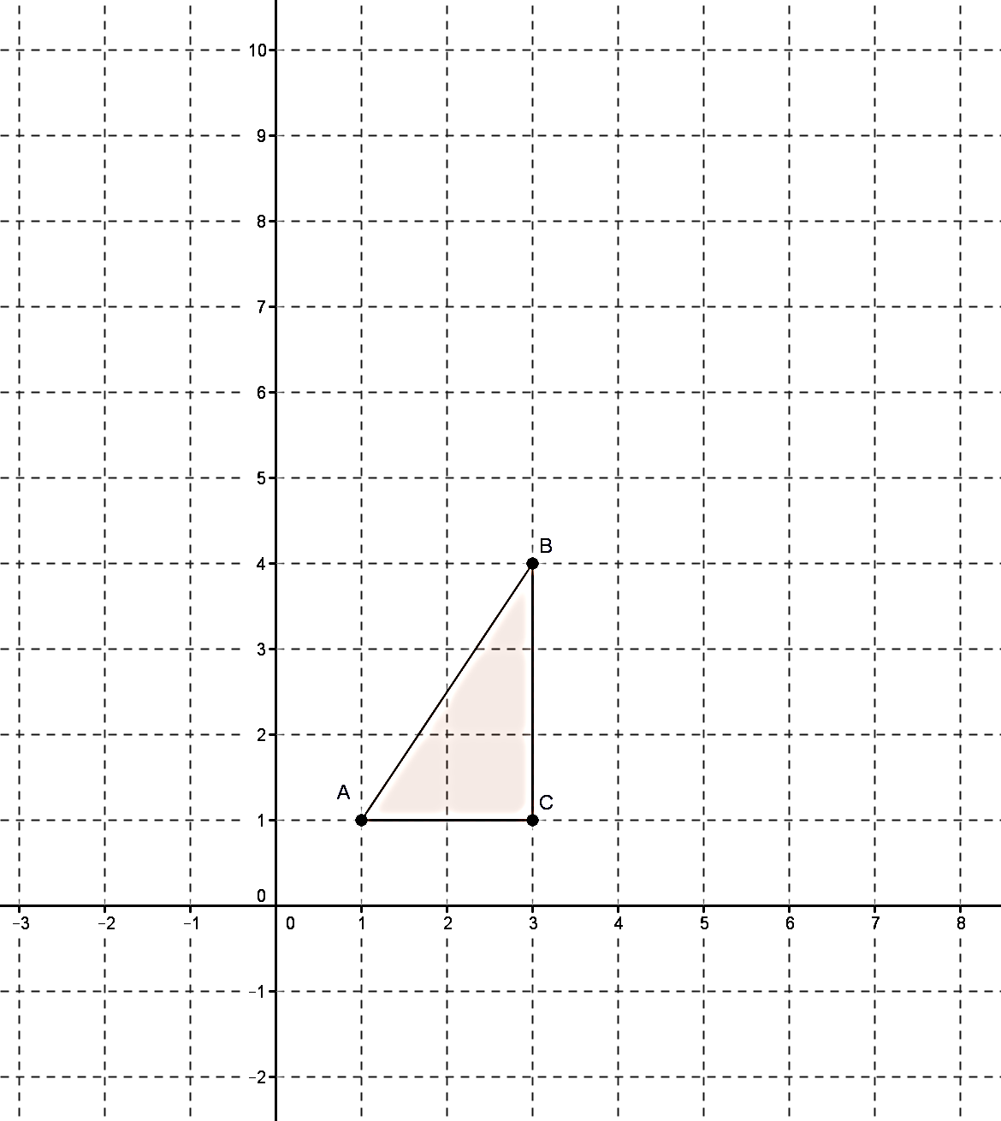 | Enlarge the shape:  - by scale factor 2, and  - centred at the origin  